OUTPUT OF PRACTICAL 1


OUTPUT OF PRACTICAL 2
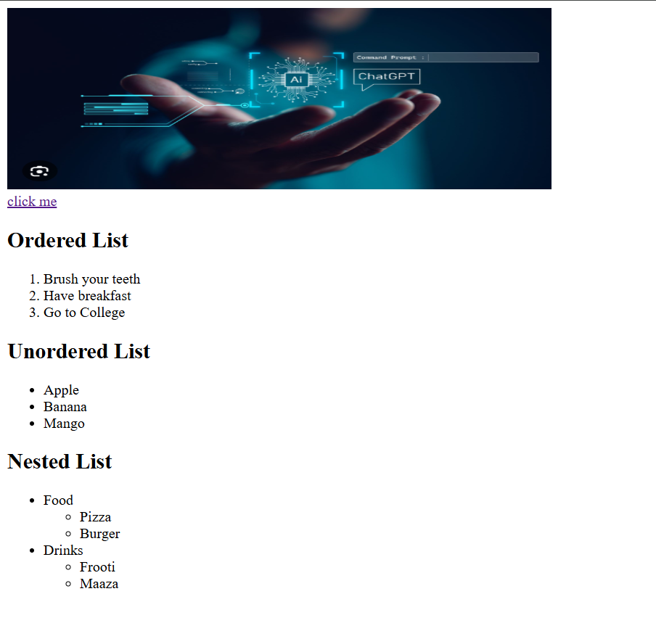
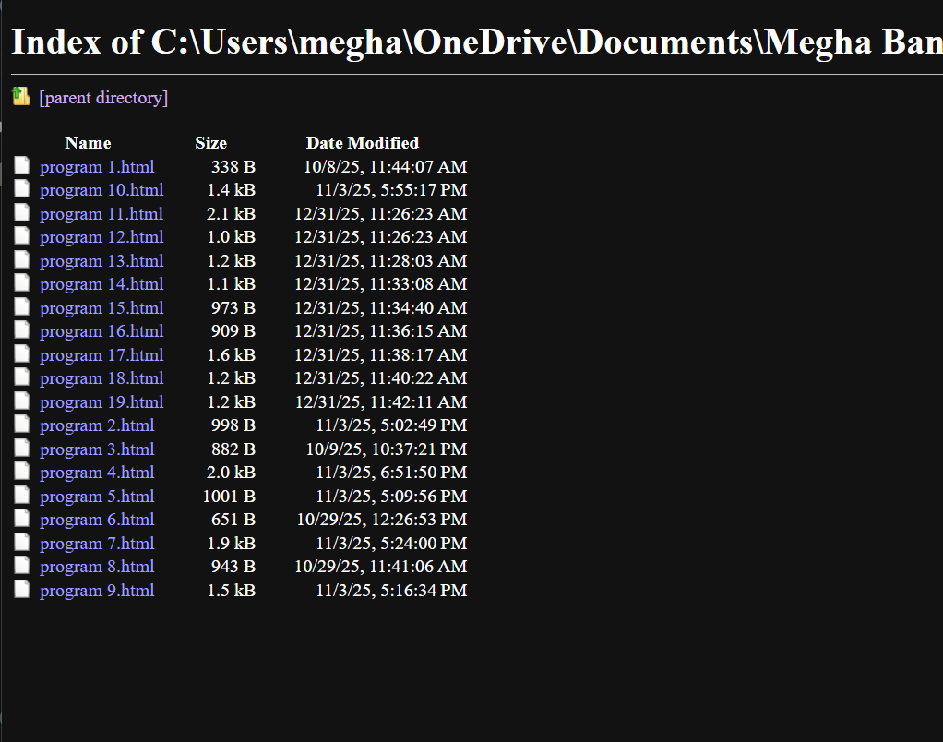

OUTPUT OF PRACTICAL 3
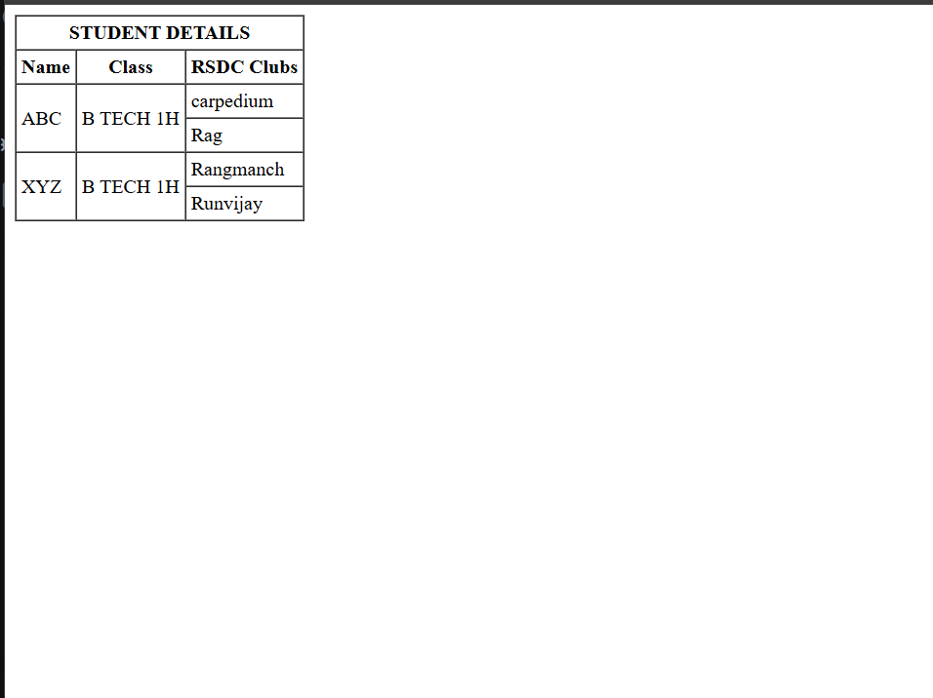
OUTPUT OF PRACTICAL 4
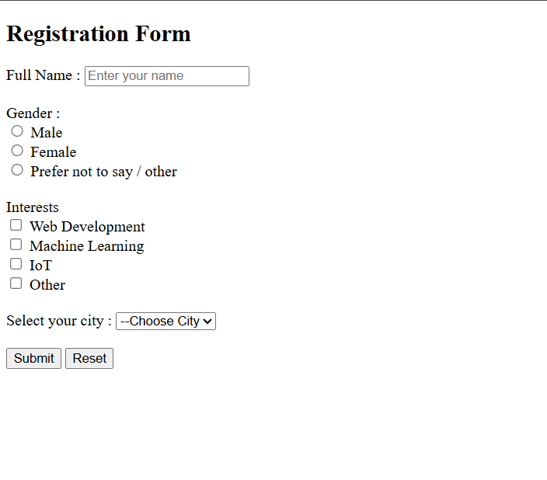
OUTPUT OF PRACTICAL 5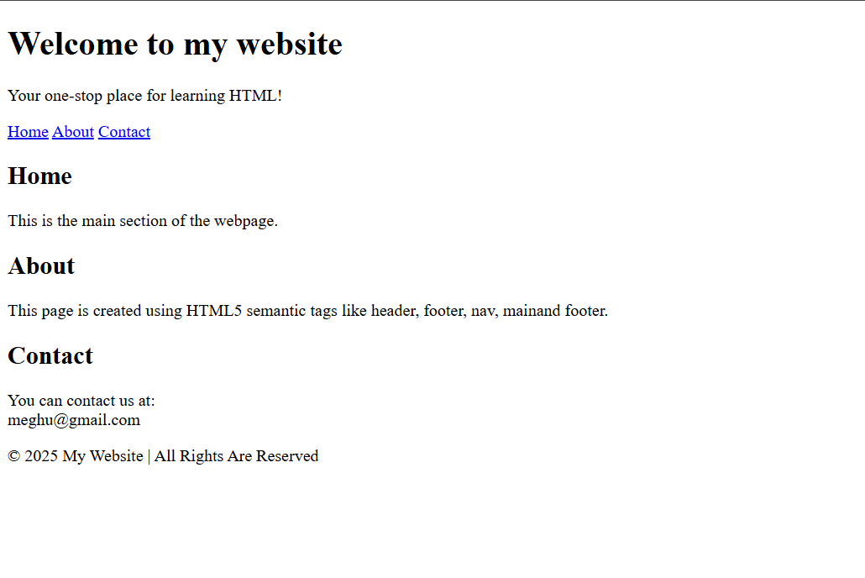
OUTPUT OF PRACTICAL 6

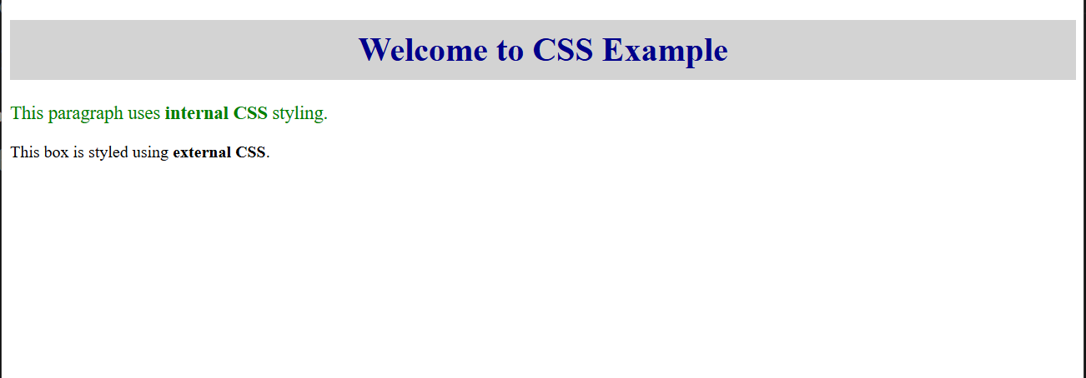

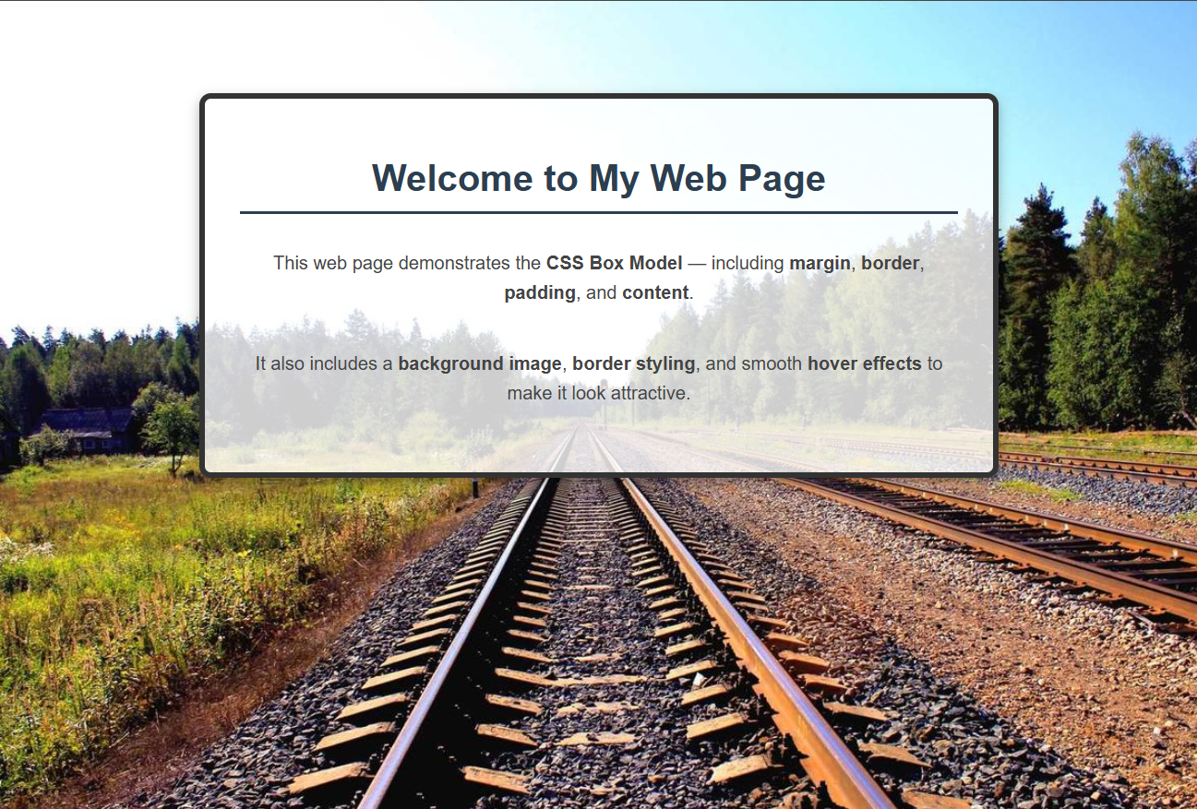
OUTPUT OF PRACTICAL 7
OUTPUT OF PRACTICAL 8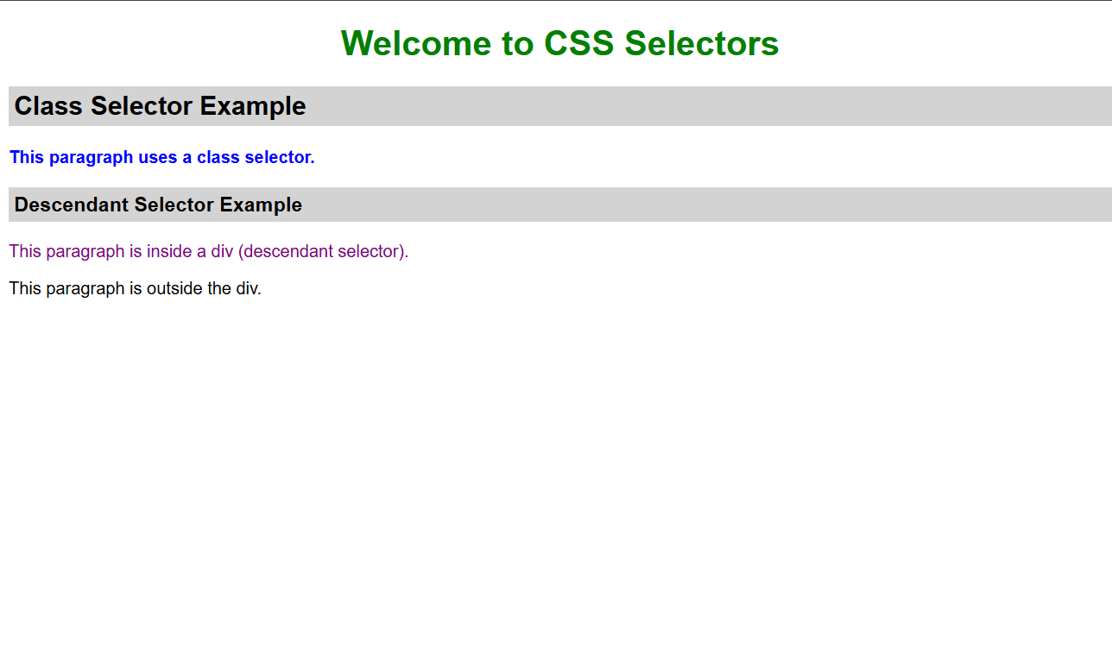

OUTPUT OF PRACTICAL 9
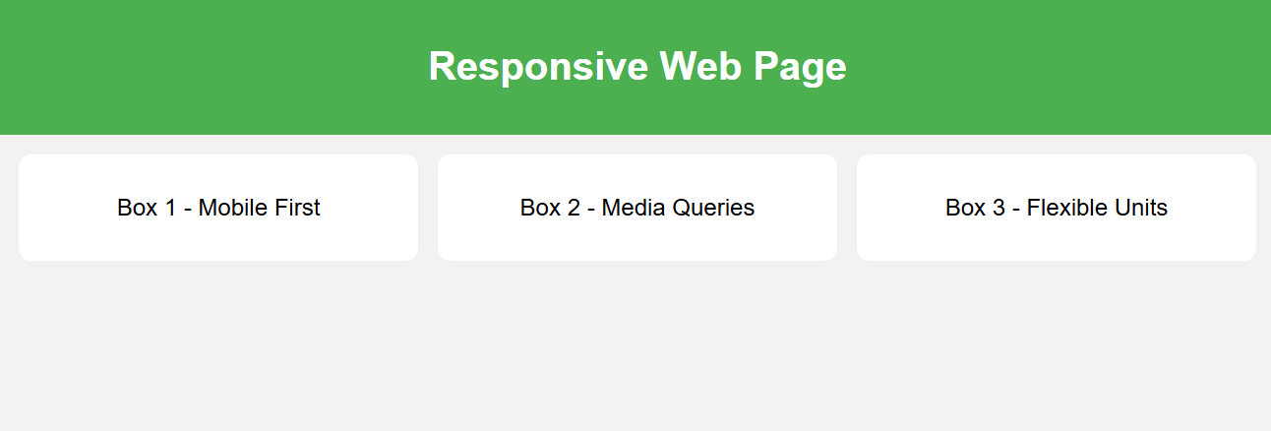
OUTPUT OF PRACTICAL 10
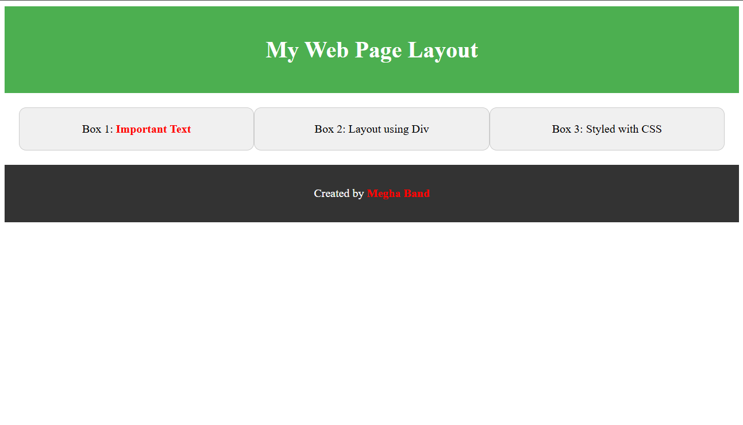
OUTPUT OF PRACTICAL 11
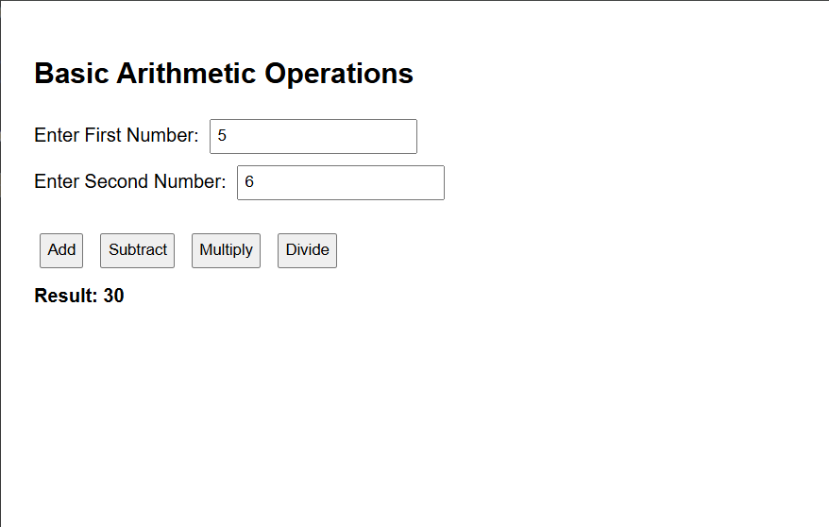
OUTPUT OF PRACTICAL 12
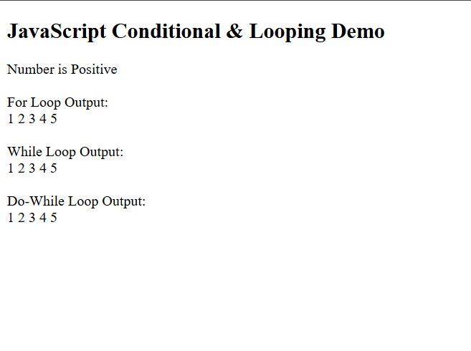
OUTPUT OF PRACTICAL 13
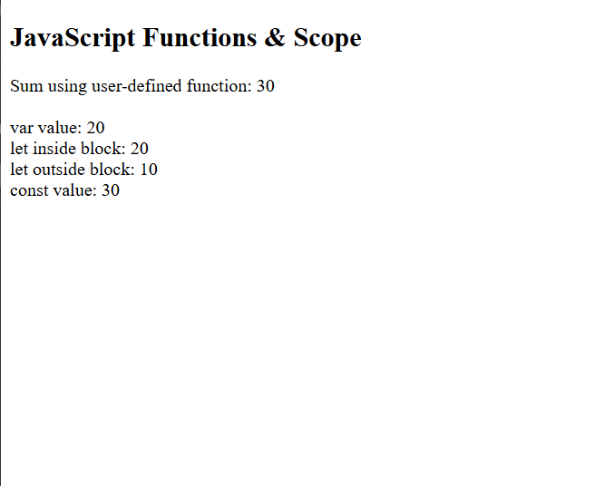
OUTPUT OF PRACTICAL 14
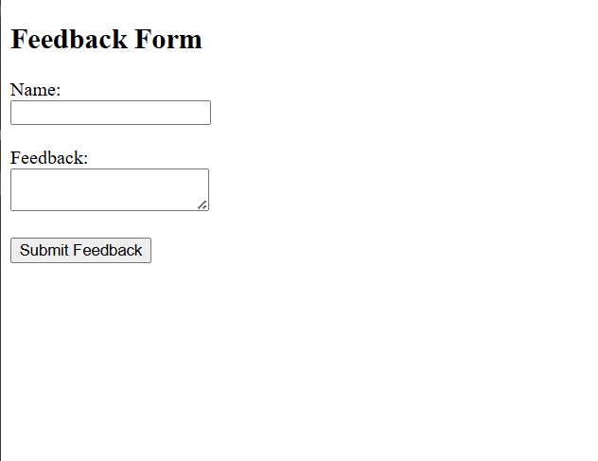
OUTPUT OF PRACTICAL 15
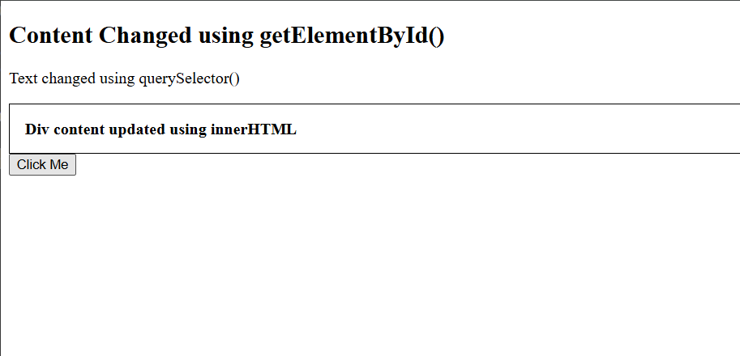

OUTPUT OF PRACTICAL 16
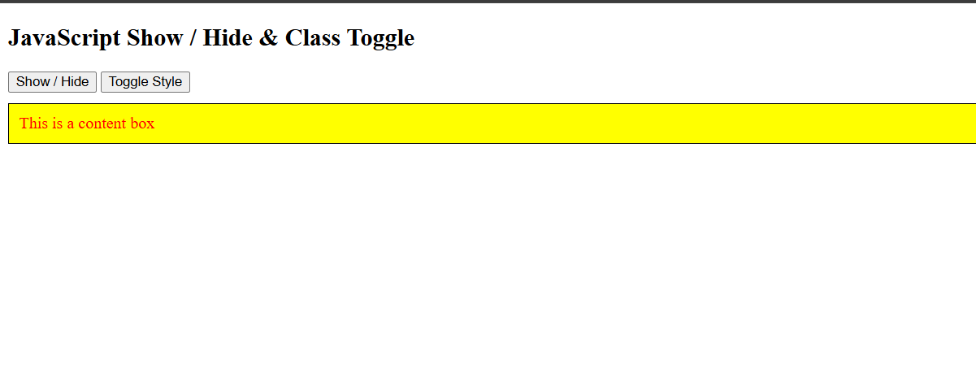
OUTPUT OF PRACTICAL 17
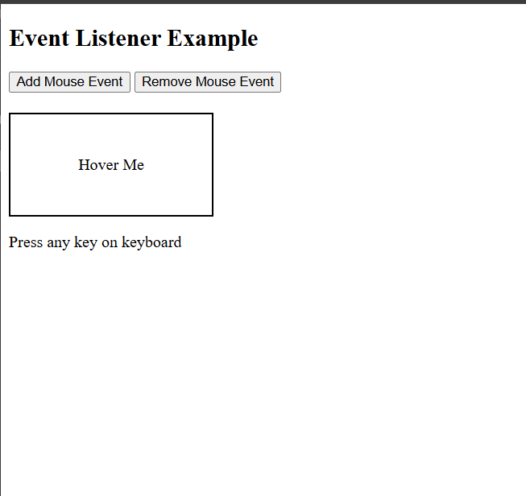

OUTPUT OF PRACTICAL 18
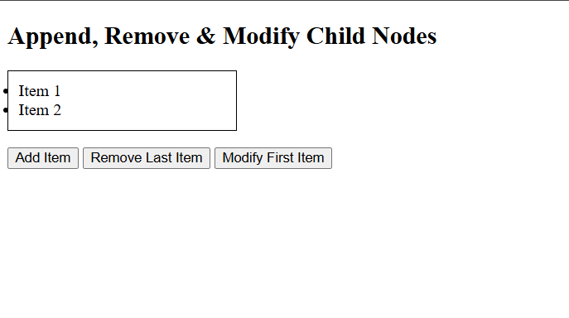
OUTPUT OF PRACTICAL 19
